DATEROEM WOOD SALES
System Documentation
Website Server (BFF)
The FastAPI service behind the customer website
Document | Website Server (BFF)
Document number | DWS-WEB-01
Version | 1.1
Date | 26 October 2026
Intended readers | Developers and maintainers of the system
Classification | Internal - contains system design details; share only with authorised staff
Describes the website server in frontend/app: what it does for the website, every route and the backend call behind it, its media file service, settings and how to run it.

Document control
Version | Date | Change
1.0 | 3 October 2026 | First complete edition, written from the source code as it stood on this date.
1.1 | 4 October 2026 | Campaigns route passes on only running campaigns with their products (Featured); sign-in by username or email and the chosen username for Google sign-up; support name and email settings.
1.1 | 7 October 2026 | Routes for the Help page's frequently asked questions and its Send us an email form (also opened from Bulk Orders); the email settings; TikTok and Instagram links for the footer.
1.1 | 8 October 2026 | Business TikTok and Instagram links set (support_tiktok, support_instagram).
1.1 | 9 October 2026 | API description pages (/docs, /redoc, /openapi.json) turned off; retired products are left out of the product routes.
1.1 | 9 October 2026 | Route for the Bulk Orders page pictures (/heavy-orders/showcase).
1.1 | 9 October 2026 | Company phone number +254182995011; /heavy-orders/contact also gives the WhatsApp link, built in one place (app/core/contacts.py).
1.1 | 17 October 2026 | The Bulk Orders email desk (ORDERS_EMAIL, the desk field of /help/email); /auth/me gives the phone number for filling in; routes for the SMS phone codes.
1.1 | 18 October 2026 | Calm error answers: backend_client.py hides technical details (503, 504, 500 sentences; the real error logged) and main.py catches the rest.
1.1 | 20 October 2026 | Route to save a signed-in customer's colour theme (PUT /auth/me/theme).
1.1 | 23 October 2026 | Route for Track my order without signing in (GET /orders/track).
1.1 | 24 October 2026 | Routes for My profile: PUT /auth/me/profile, POST /auth/me/password, POST and DELETE /auth/me/photo (the photo as the request body, a square JPEG the browser made; saved in media/profiles).
1.1 | 24 October 2026 | Named: app/core/profile_photos.py saves a profile photo (squared, at most 1 MB) as media/profiles/u<id>-<random>.jpg and deletes the old one.
1.1 | 26 October 2026 | GET /help/notices: the website's Updates. Retired campaigns never reach this server.
Keep this document up to date: when a feature, setting or server changes, edit the matching section here and add a line to the table above.
Contents
1 Introduction 3
2 Facts at a glance 5
3 What it adds on top of the backend 6
4 Routes 7
5 Source files 9
6 Send us an email 10
7 Phone codes 11
8 Errors 12
9 Configuration 13
10 Running and checking 14
11 Known limitations 15

1 Introduction
The website server is a small Python service that stands between the customer website and the Java backend - a "backend for frontend" (BFF). The browser never calls the backend directly; it calls this server under the /svc prefix, and this server calls the backend on the same computer. It also serves product and campaign photos and videos from the shared media folder.
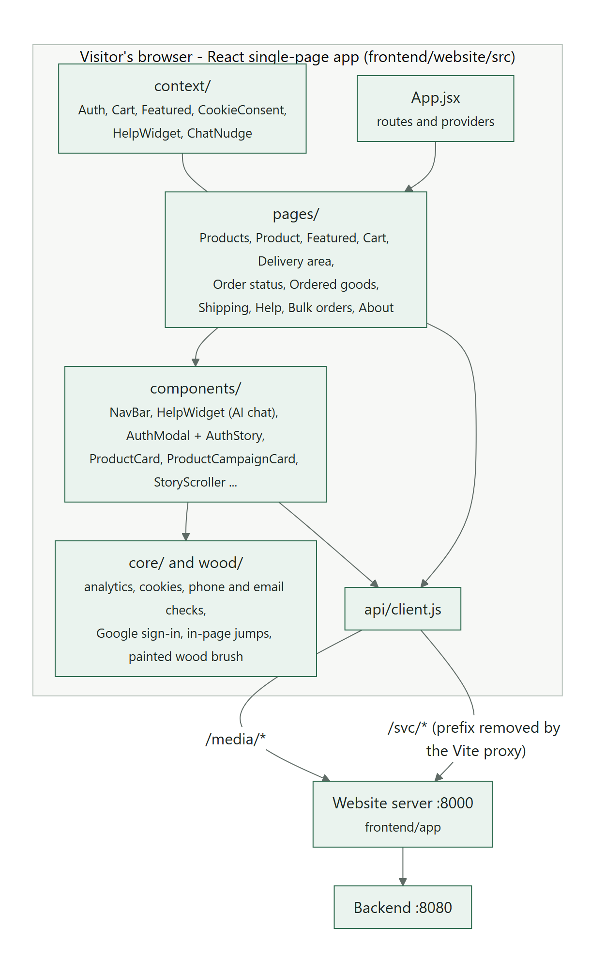
Figure 1: The website, its server and the backend

2 Facts at a glance
Item | Detail
Location | /root/fathersProject/frontend/app (virtual environment in /root/fathersProject/frontend/venv)
Framework | FastAPI on uvicorn; httpx to call the backend; pydantic-settings for configuration
Port | 8000 (all addresses)
Reached by | The website through the Vite proxy: /svc/* (prefix removed) and /media/*
Calls | The backend at BACKEND_BASE_URL (http://localhost:8080)
Start command | cd /root/fathersProject/frontend && venv/bin/uvicorn app.main:app --host 0.0.0.0 --port 8000 --reload
Started by | Desktop app Servers section ("Frontend BFF") or C:\Scripts\Launch-Dateroem.bat

3 What it adds on top of the backend
- Media files - app/main.py mounts /root/fathersProject/media at /media. The mobile server writes uploaded photos there; this server serves them to the website and the backend's image URLs point here.
- Image URL rewriting - the backend returns absolute image URLs (http://127.0.0.1:8000/media/...). core/backend_client.py rewrites them to /media/... so a visitor on another network loads them from the same public address as the page.
- Clean error messages - backend errors are reduced to their message (for example "Not enough stock: ..."); a backend that cannot be reached becomes HTTP 503 "Backend unavailable".
- Compression - JSON responses over 500 bytes are gzip-compressed.
- Sign-in boundary - checkout, order and review routes refuse requests without a token; the backend derives the customer from the token, never from the request body.
- Fallback helper - routers/help.py answers simple product and delivery questions from the catalogue and the customer's latest order when the AI assistant cannot be reached.
- Featured campaigns - routers/marketing.py passes on only campaigns that are running: status Active, today (Kenya time) within their start and end dates, and at least one linked product that is not in the bin. Each one carries its id, name, media, media type, end date and its products by name; staff-only fields (status, channel, start date) and every other campaign stay on the server. The website builds the Featured page, the Products banner and tags, and the product-page card from this one list.
- Retired campaigns (since 26 October 2026) are left out by the backend itself: this server asks for the campaign list without includeRetired.

Where to adjust: The "running" rule is _is_live in frontend/app/routers/marketing.py. The assistant uses the same rule in the backend (AiChatService.buildPromotionContext), so change both together.

4 Routes
Paths as seen by this server. The website calls them with the /svc prefix (for example /svc/products).
Note: Since 9 October 2026 the automatic API description pages (/docs, /redoc, /openapi.json) are off: this server faces the internet and those pages listed every route. The product routes leave retired products out.
Method | Path | Purpose | Backend call
GET | /health | Liveness check | -
POST | /auth/register | Website sign-up (Customer) | POST /api/auth/register
POST | /auth/login | Sign in with a username or email and password | POST /api/auth/login
GET | /auth/providers | Which sign-in options are on (Google client id) | GET /api/auth/providers
POST | /auth/google | Sign in or sign up with Google; someone new is asked for a username and phone, then sends them with the same token | POST /api/auth/google
GET | /auth/me | Check a stored token on page load | GET /api/auth/me
PUT | /auth/me/theme | Save the signed-in customer's colour theme (forest, dark or light; anything else is refused) | PUT /api/auth/me/theme
PUT | /auth/me/profile | The signed-in customer's name and email (the current password when the email changes) | PUT /api/auth/me/profile
POST | /auth/me/password | Change the password; answers a new token - every other sign-in ends | POST /api/auth/me/password
POST | /auth/me/photo | The profile photo as the request body (a square JPEG made in the browser, at most 1 MB); saved as media/profiles/u<id>-<random>.jpg, the old one deleted | PUT /api/auth/me/photo
DELETE | /auth/me/photo | Remove the profile photo (and its file) | PUT /api/auth/me/photo
GET | /products | Catalogue | GET /api/products
GET | /products/popular | Most ordered products | GET /api/products/popular
GET | /products/{id} | One product | GET /api/products/{id}
GET | /marketing/campaigns | Campaigns running now (Featured page, Products banner, product pages), each with its products by name | GET /api/marketing/campaigns, GET /api/products, then .../{id}/products per running campaign
GET | /shipping/areas | Active delivery and pickup areas | GET /api/shipping/areas
POST | /orders/checkout | Place an order (sign-in required) and send the STK push | POST /api/orders
GET | /orders/mine | The customer's orders (Ordered Goods) | GET /api/orders/mine
GET | /orders/track | Track my order without signing in: the ticket and the last 3 digits of the phone (the backend checks both and limits wrong tries) | GET /api/orders/track
GET | /orders/{id} | One order; also settles a pending payment | GET /api/orders/{id}
GET | /reviews/summary | Average rating and count per product | GET /api/reviews/summary
GET | /reviews/product/{id} | Public reviews of a product | GET /api/reviews/product/{id}
GET | /reviews/mine | Delivered products to rate and own ratings | GET /api/reviews/mine
PUT | /reviews/product/{id} | Save own rating | PUT /api/reviews/product/{id}
DELETE | /reviews/product/{id} | Remove own rating | DELETE /api/reviews/product/{id}
POST | /ai/chat | Ask the AI assistant (guest or signed in, with page context) | POST /api/ai/chat
GET | /ai/chat/status | Is the assistant available right now | GET /api/ai/chat/status
GET | /ai/chat/history | Signed-in user's saved chat | GET /api/ai/chat/history
POST | /help/chat | Keyword fallback helper used only when the assistant cannot be reached | GET /api/orders/mine, GET /api/products
GET | /help/contact | Support name, email, phone and WhatsApp, TikTok and Instagram links (empty when not set), whether the email window can send | - (from settings)
GET | /help/faqs | The Help page's published questions, in display order | GET /api/faqs
GET | /help/notices | The notices showing now (the Updates bell in the top bar), newest first | GET /api/notices
POST | /help/email | Send us an email: checks the form and sends it to the support inbox through Gmail (signed-in customers' name and email from their account) | GET /api/auth/me (signed in only)
GET | /heavy-orders/contact | Contact for bulk orders (name, email, phone, WhatsApp and its wa.me link; emailForm says whether the Send us an email window can send) | - (from settings)
GET | /heavy-orders/showcase | The Bulk Orders slideshow pictures, in order (picture address, caption) | GET /api/showcase
Table 1: Website server routes

5 Source files
File | Contents
app/main.py | App creation, CORS, gzip, /media mount, router registration
app/core/config.py | Settings (backend URL, media URL, support contacts, CORS origins, unused database and Redis settings)
app/core/backend_client.py | One function per HTTP verb, media URL rewriting, error clean-up
app/routers/*.py | auth, products, marketing, shipping, orders, reviews, ai_chat, help, heavy_orders, health
app/schemas/*.py | Request models: sign-in, Google sign-in, checkout, chat context
frontend/.env | Local overrides (backend URL, database settings - see below)

6 Send us an email
POST /help/email (app/routers/help.py, app/core/support_mail.py) sends the Send us an email window (Help and Bulk Orders pages) through the business Gmail - nothing is stored, and the message text is never written to the logs.
- To the support inbox: From "<name> (via website)" at the business Gmail, To the support address, Reply-To the customer, Subject "Website: <subject>". The body ends with the name, email, phone and whether they were signed in ("Not signed in - ... not verified" otherwise). Pressing Reply in Gmail writes to the customer.
- Which inbox (since 17 October 2026): the desk field - "orders" from the Bulk Orders page goes to ORDERS_EMAIL (the +orders address, "Dateroem Wood Sales Orders"), which also signs the copy to the customer; anything else goes to the support address. The body names the page the message came from.
- To the customer: signed in, a copy of their message at their account email; not signed in, a short note without their text ("A message was sent to Dateroem from our website with this email address ..."), at most twice a day per address - so the form can't be used to send strangers a message that seems to come from Dateroem.
- Never anywhere else: the recipient is fixed, every header is set by the server, the address is checked strictly and line breaks in headers are refused.
- Limits: 3 an hour and 10 a day per sender address; 30 an hour and 120 a day for the whole site (Gmail allows about 500 a day). Through the ngrok tunnel every visitor has the same address, so the limits are per email and overall. A filled-in hidden field or a form sent within 3 seconds is answered as sent but not sent.
- Errors: 400 with what to fix, 429 when a limit is reached, 503 "Sending isn't working right now - please use your own email app (link below)." when Gmail refuses or can't be reached.

Where to adjust: Limits: PER_ADDRESS, OVERALL, GUEST_NOTES_PER_DAY, MIN_WRITING_MS and MAX_MESSAGE in app/core/support_mail.py; the wording of both emails is in the same file.

7 Phone codes
Since 17 October 2026: /auth/phone/send-code and /auth/phone/verify (sign-up) and /auth/me/phone/send-code and /auth/me/phone/verify (signed in) pass straight to the backend (app/routers/auth.py, PhoneCodeRequest in app/schemas/auth.py); /auth/register and /auth/google carry phone_proof. The backend sends the SMS and keeps every limit. /auth/me gives the account's phone number (filled in at checkout and in the email window) and phoneCodeRequired.

8 Errors
Errors (since 18 October 2026): app/core/backend_client.py never passes on technical details. A backend that can't be reached becomes 503 "We can't reach our server right now ...", a slow one 504, and any backend 500 becomes "Something went wrong on our side ..." - the real error goes to this server's log. A reason the backend wrote for people (any 4xx, or a deliberate 503 such as "Text messages are not set up yet.") passes through; a 4xx without one gets a plain sentence for its status. app/main.py answers a request with fields that don't fit with one sentence (422) and anything unexpected with the calm 500, logging the trace.

9 Configuration
Settings are read from environment variables or frontend/.env (app/core/config.py).
Setting | Default | Purpose
BACKEND_BASE_URL | http://localhost:8080 | Where the backend is
MEDIA_BASE_URL | http://127.0.0.1:8000/media/ | Must equal the backend's app.media.base-url, so image URLs can be rewritten
SUPPORT_NAME, SUPPORT_EMAIL | Dateroem Wood Sales Support, dateroemwoodsales+support@gmail.com | The Help page's email button (name and address); the email is also quoted by the assistant and the fallback helper
ORDERS_NAME, ORDERS_EMAIL | Dateroem Wood Sales Orders, dateroemwoodsales+orders@gmail.com | The Bulk Orders page's email desk (since 17 October 2026): its messages go here and the copies come from here
SUPPORT_PHONE, SUPPORT_WHATSAPP | +254182995011 (the company number since 9 October 2026; defaults in app/core/config.py) | Calls and WhatsApp on the Help page, the Bulk Orders page and the footer, and the chat helper's fallback answer; the WhatsApp link is built by app/core/contacts.py. How to change it: DWS-CFG-01, Changing the company phone number
SUPPORT_TIKTOK, SUPPORT_INSTAGRAM | https://www.tiktok.com/@dateroem.woods, https://www.instagram.com/dateroem.woods/ | The business TikTok and Instagram pages (set 8 October 2026), shown in every page's footer; an empty one is not shown. Use the plain address, without the tracking part a Share button adds (?_r=..., ?stkn=...)
SMTP_USER, SMTP_APP_PASSWORD | empty (set in frontend/.env) | The business Gmail and an App Password for it, used to send the Send us an email form; while either is empty the email buttons open the visitor's email app instead (emailForm false in /help/contact and /heavy-orders/contact). The password is a secret - see the Configuration and Secrets Reference
SMTP_HOST, SMTP_PORT | smtp.gmail.com, 465 | Gmail's sending server (encrypted connection)
CORS_ORIGINS | localhost:5173, 127.0.0.1:5173, localhost:3000 | Browser origins allowed to call this server directly
DB_HOST, DB_PORT, DB_NAME, DB_USER, DB_PASSWORD | localhost, 3309, dateroem, dateroem_frontend | Reserved - not used; all data comes through the backend
REDIS_URL | redis://localhost:6379/0 | Reserved for a future cache - not used

Where to adjust: Business contact details shown to customers: support_name, support_email, support_phone, support_whatsapp, support_tiktok, support_instagram in frontend/app/core/config.py (or the matching environment variables). The email is the business Gmail (dateroemwoodsales@gmail.com) with a "+support" tag: it arrives in that mailbox, where a Gmail filter files it under the Customers label. Confirm the phone and WhatsApp number before launch.
If the website is served from a real domain that calls this server directly, add that origin to cors_origins.

10 Running and checking
cd /root/fathersProject/frontend
venv/bin/uvicorn app.main:app --host 0.0.0.0 --port 8000 --reload

curl http://127.0.0.1:8000/health # {"status": "ok"}
curl http://127.0.0.1:8000/products | head -c 300
With --reload the server restarts by itself when a Python file changes. Dependencies are installed in frontend/venv from frontend/requirements.txt.

11 Known limitations
- No caching: if the backend is down, every request returns 503. A cache (Redis is already configured) is listed as future work in backend_client.py.
- The help fallback is a simple keyword matcher, not an assistant.

